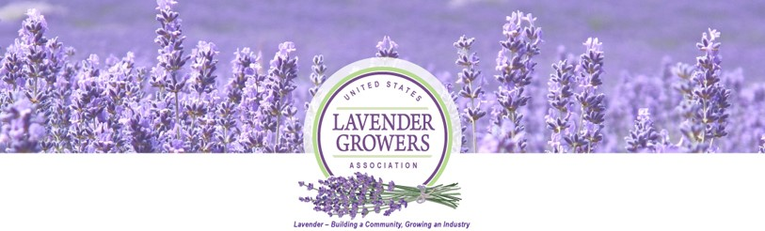

Front Porch Series – Fast Facts

Title: Starting a Healthy “Root”-ine”: Lavender Propagation by Cuttings
Event Date: Thursday, July 11, 2024
Featured Presenter: Jacob Hurst, M.S. Lecturer, M.S. Plant Science, Fresno State
Facilitators: Barbara Cesiro & Mary Pilotte, Co-Chairs, USLGA Education & Research Committee,
Tech Support: Michele Hyson, Executive Director

Event Goal: This FPE is a journey through the process of propagation by the use of cuttings, led by plant health lecturer and propagation expert Jacob Hurst. We learn how new roots are formed, strategies to encourage rapid and uniform rooting of cuttings, and how to safely acclimate your new plants to life in the field or nursery. Special attention will be devoted to regional challenges to propagation by cuttings and organic production systems.

Terms used during the event: This is a technical presentation. There are many technical terms that inform the topic of plant propagation and are important to understand for propagation success.
- Primordial root -root material existing in the plant ready to emerge, such as that seen in some fruit tree stalks, orchids, etc. Plants with primordial root “initials” are very easy to propagate.
- Root Initials – the initial cells used to form/develop roots.
- Callus – a stage of cell division on the area on the plant where the cutting occurred.
- Cutting -a portion of the donor plant that is taken to propagate a new plant.
- Sticking – the process of poking the cutting into planting medium/material to begin/nurture the propagated plant.
- Rooting hormone -material used to put onto the cutting to increase rooting success. Common hormones include: (IBA) Indole 3-Butyric Acid and (NAA) Naphthalene Acetic Acid.
- Humidity Dome – a humidity dome is a covering for seeding and propagation trays used to help manage operating conditions/humidity of the cutting or newly planted seed.
- Cold Frame – an unheated protective structure used to protect new cuttings from weather conditions as they form their roots. Different from a greenhouse in that it uses only the sun for protective heat.
- Acclimation – is the process of “hardening off” your newly propagated plants, so they are able to sustain life under field conditions. This involves gradual exposure to light, reduced humidity environment, etc.
- Softwood – the new growth of a plant, typically used for cutting material.
- Semi Hardwood – material growth older than new growth, but less than 1 year old. Some browning of stem may be apparent.
- Micronutrients – nutrients beneficial to plant propagation. Generally, this includes nitrogen, phosphorus, and potassium (N-P-K).
- Co co coir – coconut fiber material, sometimes used for planting/propagation material in place of vermiculite or perlite.
- Node - place on a plant stem where buds or leaves originate.

Key Points Summary:
- Lavender does not have preformed root initials​, meaning propagation is necessary, however lavender tends to propagate somewhat easily with or without rooting hormone.
- The ideal cutting size is 1-4” long with a minimum of one node for rooting to hopefully occur. *Pro-Tip* - avoid donor material that is blooming (in the reproductive stage), rather take foliar (leafy) tips.
- *Pro-Tip* Early morning is the best time to take cuttings for propagation. This is due to lower early morning temperatures, and the donor plant being in the best position of water intake at that time of day.
- *Pro-Tip* - When harvesting tips for propagation, place in a plastic bag to retain moisture, and stick as quickly as possible to avoid drought stress.
- There are 5 critical stages of root formation, identified as Stage 0-4: Donor selection, Harvest & Sticking, Early physiological changes​, Formation of Root initials and/or callus, Root elongation/emergence​.
- It takes 4-5 weeks for a propagated plant to develop roots and be ready to begin the process of hardening off.
- Stage 0 - Selection of donor plants for propagation is key. This includes the “sweet spot” age of donor material for the cutting, varieties that are conducive to propagation, and healthy pest/disease-free plants that are not suffering from malnutrition or dehydration. *Pro-Tip* - avoid propagating sick plants, to avoid the chance of transferring the disease/virus, etc.
- Ideal temps for propagation are 70-75 F medium temp, with bottom heating being ideal. Ideal humidity at initial propagation is 80-90%.
- Newly propagated plants require a period of acclimatizing, to ensure they will be successful in the field when transplanted. This includes decreased humidity, gradual increases in light (utilizing shade/or protective covered areas for hardening off), and mild temperatures. *Pro-Tip* - the use of 50% shade cloth or a shady location can be helpful in keeping just enough light on propagated plants to prevent them from reaching toward/for light sources.
- *Pro-Tip* While lavender is not a “heavy feeder”, you can fertilize new propagated starts at the rate of 200ppm N at every watering, however, it is not required and can be a waste of resources.
- *Pro-Tip* Organic options exist for rooting hormones including compost tea and willow water. If willow water is used, make sure to sterilize the water, to prevent rot in the newly propagated plants.
- Each region faces its own challenges that work for and against successful propagation. With this in mind, know your region, and connect with others in your region who are successfully propagating.

Other Session Notes: Attendees – 52

Other sites used in support of Fast Facts: Michigan State University: rooting_perennials_july_2017.pdf (msu.edu)
Q & A
Q: Light requirements of newly propagated plants?
A: See the above notes.
Q: Planting matter mixtures that could be ideal?
A: Some successful experience with a mixture of perlite and coco coir, which offers a balance of water retention and aeration.
Q: How do planting pucks (soil cubes) do as planting matter?
A: The issue is how they retain water. Too much water retention can be a problem, they are however a convenient option to be explored for some.
Q: How old are plants that are propagated and sold by nurseries?
A: Plants sold by nurseries are different ages depending on the size/selling price. Make sure to inquire what the transfer and hardening off recommendations are from each nursery that you purchase from, to maximize your success.

